Your Hormone Health: A to Z


Alicia Stanton, M.D., Author
Hormone Harmony: How to Balance Insulin, Cortisol, Thyroid, Estrogen, Progesterone and Testosterone to Live Your Best Life

draliciastanton.com

In today’s society, we place so many demands on our bodies that the natural functioning of our hormones is being disrupted, causing a wide range of symptoms such as lack of energy, loss of zest for life, weight gain, mood swings, hot flashes, loss of sex drive, sleep disturbances, fuzzy thinking, forgetfulness and many more. We are living longer lives and with that come more responsibilities. Women are multitasking as caregivers while carrying on challenging careers. To say our lives are stressful would be an enormous understatement. Our lifestyles can place additional stress on our bodies, with inadequate nutrients in our food, too many unhealthy calories, lack of physical activity and toxins in the environment. It is no wonder our hormones are out of balance.


Many people don’t realize the impact our hormones can have on our overall health. Our hormones are designed to work together to do different jobs. Hormones deliver messages from one part of the body to another, from the cells to the brain, from the brain to the glands and from the glands to the cells. So when one hormone malfunctions, it sets off a chain reaction that interferes with the functions of the others, bringing about hormonal havoc. Harmony is restored by getting all the right parts back in balance.

Believe it or not, just by making changes in the way we live, we can remove the triggers of imbalance – eating the wrong foods, being overweight, chronic stress, exposure to too many toxics, getting too little or too much exercise and lacking the optimum amounts of essential nutrients – and we can regain hormonal balance to achieve optimal health.

Here is your A to Z guide to achieve and maintain your hormone health:

A: Adrenals – The adrenal glands produce the hormone cortisol. When we experience prolonged stress our adrenal glands can no longer produce adequate amounts of cortisol, which leads to adrenal fatigue. Symptoms one experiences include severe morning fatigue, difficulty getting out of bed, difficulty concentrating and making decisions, anxiety, depression, feelings of being overwhelmed and symptoms of low blood sugar, which may include feeling dizzy or weak.

B: BPA – Bisphenol A is a chemical used in making plastic products like water bottles and lines the inside of cans. The chemical can leach into our food, and since it is a synthetic estrogen, it mimics our bodies’ natural estrogen, which contributes to unhealthy, elevated levels of the hormone and disrupts balance with progesterone and testosterone. It is important to reduce our exposure to this toxin as well as other environmental toxins. Try buying BPA-free products and avoid synthetic fragrances found in many household and beauty products.

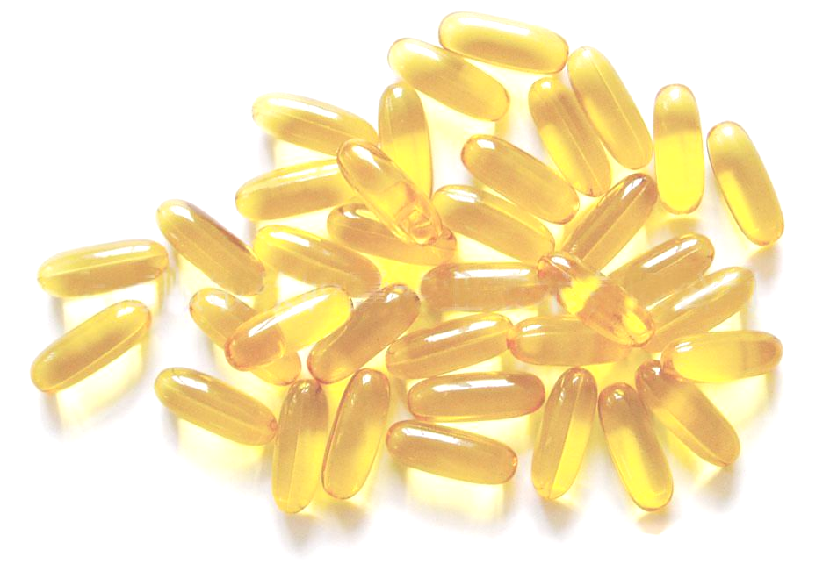
C: Cortisol – Cortisol is our flight or fight hormone, enabling us to function in stressful situations. Chronic stress and spikes and crashes of blood sugar from the foods we eat can lead to an overproduction of cortisol. When cortisol levels go awry it can lead us to have low energy levels in the morning and after dinner start to rise, which interrupts our ability to get a good night’s sleep. Cortisol overproduction also triggers an imbalance in sex hormones because it depletes our levels of progesterone.

D: Depression-busters – Exercise triggers the production of endorphins, feel-good chemicals that prevent and alleviate depression. Fish oil and other omega-3 fatty acids have shown to reduce mental pain and feelings of depression.

E: Estrogen – A sex hormone that performs over 400 functions in the female body! It maintains memory, mood and muscles. It protects against heart disease and maintains bone mass and protects against osteoporosis. As we age, estrogen levels decrease and symptoms of getting older set in – such as less sex drive, less muscle and bone mass and less zip overall.
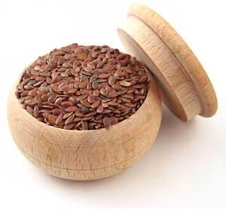
F: Flaxseed – The oil in flaxseed is the richest plant source of omega-3 fats and the seeds are a good source of fiber. Eating 1-2 tablespoons of flaxseed daily may help to reduce risk for heart disease and cancer. Add toasted flaxseeds to salads, soups and sandwiches for a tasty crunch and ground seeds can be added to smoothies.

G: Glycemic Index – A system of measuring how quickly foods convert into blood sugar. For stable blood sugar, decreased risk of disease and balance hormones, carbohydrates that are staples in our diets should convert slowly, or have a low GI. Think non-starchy vegetables, fruits from northern climates, sourdough and whole grain breads, rolled oats, nuts and seeds, quinoa and barley, beans and legumes and milk and plain yogurt.

H: Hot Flashes – Everyone associates hot flashes with menopause, which is accurate, but hot flashes can occur anytime there is a fluctuation of female sex hormones. This can occur prior to menopause, triggered by child bearing, perimenopause and factors outside of the female body. However, studies have shown that women who are overweight are more likely to suffer from hot flashes and more bothersome ones as well. Vitamin E, fish oil, black cohosh and bioidentical hormones can all help relieve hot flashes.

I: Insulin – As we live longer, insulin levels increase, contributing to the aging process and having a tear-down effect. Higher levels of insulin contribute to higher blood pressure, higher cholesterol and weight gain, which increases inflammation. Insulin is the most common trigger of imbalance to other hormones. In order to keep insulin levels down, it is important to not consume too much refined flour and sugar as they convert into blood glucose very rapidly, causing insulin to spike. Too much sugar in the blood causes muscle cells to shutdown – insulin resistance.


J: Joint Function – Many women start to experience joint pain as they enter into perimenopause. This is most likely attributed to diminishing estrogen levels. Estrogen works as an anti-inflammatory, so when estrogen is down, it causes joint pain and other inflammation to worsen. Ways to ease joint pain include exercise, eating properly, drinking lots of water to stay hydrated, not consuming caffeine and taking a daily multivitamin that has vitamins B, C, E and A. Yoga can also be beneficial to ease joint pain because it helps stretch the body and improve flexibility.

K: Kick ass sex! – As we age, levels of four hormones – estrogen, progesterone, testosterone and thyroid – start to go down and symptoms of getting older, like less sex drive, start setting in. Simple lifestyle changes like exercising and eating right can bring these hormones back up, making you feel great, and ultimately improving sex drive and desire. In some cases, women may need to have their levels checked by a physician and prescribed bioidentical hormones can do the trick to relieve all the symptoms a woman is experiencing. The bonus is a renewed desire and a kick ass sex life well into midlife!

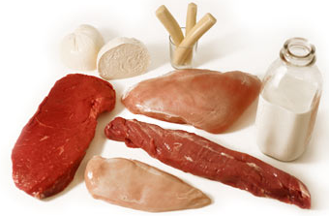
L: Lean protein – Any type of lean protein has a beneficial effect on blood sugar and helps reverse and prevent insulin resistance - the chief cause of hormonal imbalance. Include a lean protein – eggs, lean beef, pork and poultry – in every meal to minimize triggers of hormonal imbalance.

M: Menopause and Perimenopause – Menopause means a woman hasn’t had a menstrual period for 12 months. Perimenopause is the transition period leading up to menopause, which produces fluctuations in hormone levels that cause hot flashes and other symptoms. However, this natural cycle is often exasperated by what we eat and how we live our lives. Poor nutrition, chronic stress and environmental toxins all upset the healthy interplay of our hormones. As a result, the natural aging process becomes more intense and symptoms of aging start to appear earlier in life.

N: Nutrition – Through proper nutrition, you can take back control of your hormones to bring balance and achieve optimal health.

O: Omega-3s – Healthy fats found in fish, flax and olive oil that are necessary for the function of every cell. They reduce inflammation; help balance hormones; reduce the risk for heart disease, diabetes and inflammatory diseases such as arthritis; support healthy function of the brain and nervous system and protect against mood swings and depression.

P: Progesterone – A sex hormone that decreases as we age. It helps build us up and balances the effects of estrogen. Progesterone protects against heart disease, has a calming effect and enhances mood, balances blood sugar and thyroid function and rebuilds bone.

Q: Quinoa – A protein and nutrient-rich seed offering benefits for tissue growth and repair, easing migraine headaches, preventing and reversing insulin resistance and preventing diabetes and heart disease. Eating a serving of whole grains, such as quinoa, six times a week is especially good for postmenopausal women with high cholesterol, high blood pressure and other signs of cardiovascular disease. Studies have also shown the fiber from whole grains offers significant protection against breast cancer for pre-menopausal women.

R: Rest – Non-optimum levels of estrogen, progesterone and testosterone can cause a flurry of sleep issues and debilitating fatigue. Progesterone initiates sleep and estrogen helps keep sleep going, uninterrupted. Cortisol malfunctions can interfere with restful sleep, so it is important to eat right and manage stress in order keep hormones functioning properly.

S: Stress Management – Managing stress is essential for hormone health. Chronic stress can cause an overproduction of cortisol, which can lead to adrenal fatigue, hormonal imbalances and hinder how we react in stressful situations. To start reducing the ongoing stress in your life, give yourself a recess, even if only for a few minutes. Go for a walk, take few deep breaths, do a crossword puzzle, whatever it is that works for you.

T: Testosterone – Like estrogen and progesterone, testosterone is a sex hormone that decreases as we live longer. It has pivotal functions in the female body, including building muscles and promoting muscle tone, increasing energy and libido, enhancing a sense of well-being and strengthening bone.


U: Unwind – Everyday, be sure to take time out and do something you enjoy that helps you unwind from all the noise in your life. Go for a walk, read a book, or draw a bubble bath to unplug from the digital world. Allow your mind and body to slow down. Even if it’s just for 15 minutes, this ME time will help get rid of stress and get a better night’s sleep.

V: Vitamin Supplements – Supplements are not to be used as a substitute for a healthy diet, but rather to help fill in the gaps and provide nutritional support to help meet the challenges your body faces from the environment and stress of life. A good place to start is with a good quality multivitamin, mineral and antioxidant combination, accompanied with fish oil and CoQ10, which are not found in multivitamins. And for optimum health, magnesium and Vitamins C and D should be considered.

W: Weight Gain – Eating high-GI carbohydrates leads to weight gain because it tricks the body into thinking it is starving. The way to combat against this is by eating foods that slowly increase blood-sugar levels and keep them stable. Eat low-GI foods every three hours or so to achieve this. Excess weight has been shown to increase the odds of experiencing more uncomfortable and intense symptoms of hormonal imbalance and at an earlier age.


X: eXercise – Physical activity plays a key role in reversing insulin resistance. With the right exercise, the body can build new muscle cells. To reap the full benefits, you need strength training for your muscles and aerobic exercise for your heart. Exercise provides a host of other benefits as well, including making you happy and stabilizing mood swings, keeping blood sugar stable, controlling weight and appetite, keeping bones strong, preventing cancers and diabetes, improving joint function, good for your heart, reducing risk of stroke, protecting vision and maintaining a healthy brain.

Y: Youth – Keep your youth by balancing hormones. Remember, when estrogen, progesterone, testosterone and thyroid start to decrease the symptoms of aging start to set in. Slow down the aging process by keeping levels of insulin and cortisol low through proper nutrition, stress management and the right amounts of exercise.

Z: Zinc – It is found in every cell and required by more than 300 enzymes for optimum function. It helps insulin do its job, which is critical to balanced hormones, and it is an antioxidant. Zinc is necessary for immune function, skin, eyes, fertility, wound healing and overall health.

